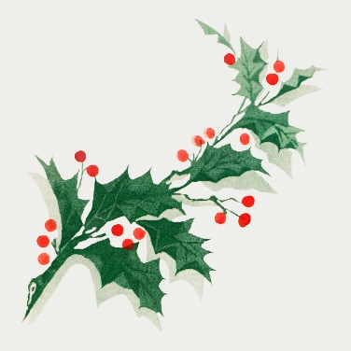
CHRISTMAS OPENING HOURS 2025
Monday 22nd December 6.30 - 11.00 pm
Tuesday 23rd December 6.30 - 11.00 pm
Wednesday 24th December 6.30 - 11.00 pm
Thursday 25th December CLOSED
Friday 26th December CLOSED
Saturday 27th December 6.30 - 11.45 pm
Sunday 28th December 12.00 - 3.00 pm
Monday 29th December 6.30 - 11.00 pm
Tuesday 30th December 6.30 - 11.00 pm
Wednesday 31st December 7.00 – 1.00 am
Thursday 1st January 2026 CLOSED
Friday 2nd January 2026 12.00 – 11.45 pm
Saturday 3rd January 2026 6.30 – 11.45 pm
Sunday 4th January 2026 12.00 – 3.00 pm

